**Sling redirect**

* Using sling redirect you can redirect to different page by hitting a URL of other page.
* It can be achieved using sling redirect.
* In this scenario, we can see how to redirect to English page by hitting the root page.

**Steps to be followed**

* We need to add 3 properties in the jcr:content node of page as follows:
  + redirectTarget : /content/we-train/en
  + Sling:redirect : true
  + Sling:redirectStatus : 302
  + Modify sling:resourceType = foundation/components/redirect ( this is the redirect component available out of the box).
* 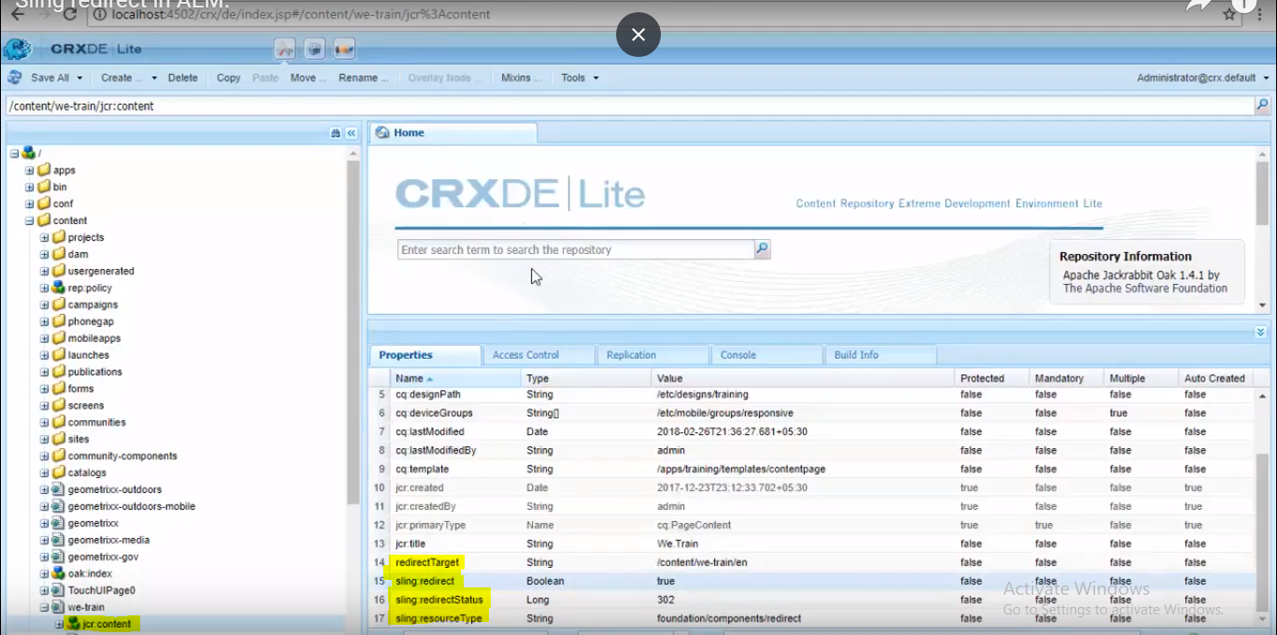

**Scenario:**

If the pages are auto generated, there will be parent page which has no content to display. Its actual child will have the content to display. So we can put add these sling properties on the parent jcr:content node, so that it will be redirected to its child page.

Consider the below page structre.

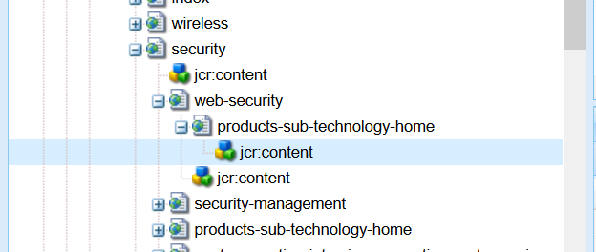

web-security is an empty page, and its actual content can be accessed with products-sub-technology-home.

So accessing web-security page should be redirected to products-sub-technology-home.

While generating the pages (using script), we can set the sling properties dynamically with child page path as sling:redirectUrl value.